

**MAIDSTONE SPECIALIST TEACHING & LEARNING SERVICE**

**Leaflet / Information Sheet**

|  |
| --- |
| **Establishing Joint Attention: Intensive Interactions** |

The first stage to establishing joint attention is Intensive Interactions.

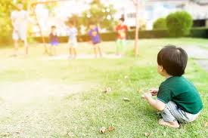

Intensive Interactions are a fun activity you can do individually with all children, but would also benefit children who are anxious, pre-verbal, struggling to form strong relationships and who avoid interactions with others.

Intensive Interactions will support a child to:

* learn how to share personal space
* enjoy sharing time with another person
* encourage development of their concentration and attention skills
* support them to realise that adults are useful and fun, and are not just for giving instructions/directions.

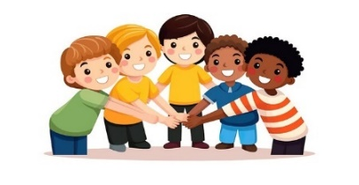Often, when a child realises you are copying them and that they are taking the lead, this can be a wonderful experience for the child. In some cases, this could be the first time that the child has recognised that they are playing with another. This is when the child will start to share joint attention with the adult. It is essential that this is reciprocal, so that both the child and the adult get equal enjoyment.

When a child realises that their movements, their sounds and their actions, can convey meaning to others, this can support the child’s sense of belonging.

**How to begin**

Intensive Interactions are **always** led by the child, and the adult **must** join the child in their play. This is not an intervention that can be timetabled and should happen naturally when a child is playing. Begin by the adult being a short distance away, and for very short periods of time so that it does not overwhelm the child.

The adult will copy what the child is doing, exactly – their movements, their sounds, their actions. This means that the child takes the lead, meaning that there is no pressure or expectation from the adult. The only outcome is sharing attention, connecting together, being playful and having fun.

*For example:*

* If the child is silent, then the adult is silent,
* If the child is humming, then the adult is humming,
* If the child is waving their arm, then the adult is waving their arm,
* If the child is spinning around, then the adult will be spinning around,
* If the child is lining up objects, then the adult will do the same (with a different set of objects), and so on.

Remember at all times to be respectful of what the child is doing.

**Whether you get a response or not, continue copying.**

**Getting a response can take a very long time, so be patient and keep going.**

**Remember:** If the child gets frustrated with you, then this is still a response and the child has noticed you are there - which is the beginning of what you want to achieve - if the child continues to get frustrated, step back a little and try again another time.

**To progress this further**

After several successful sessions of the child accepting you coping their movements, sounds, actions, the adult could try to take the lead very briefly. This can be done by adding or change something that you are copying, but only very slightly. Depending on what the child is doing, this could be a different sound, a different action, or a different movement. This is to see if the child copies you or gives a response in some way. This response could be the child letting you know that they are not ready for you to take the lead, yet.

*For example:*

* The adult could take the lead by briefly by naming the vehicles, or perhaps counting them - the adult may stop after counting, “1, 2, 3,” and then pause in the hope that the child may say or indicate “4”.

When the child’s response to your change is consistent, you can include more - however remember to do this gradually over time, so as not to overwhelm the child.