

**MAIDSTONE SPECIALIST TEACHING & LEARNING SERVICE**

**Leaflet / Information Sheet**

|  |
| --- |
| **Establishing Joint Attention: People Games** |

People Games are games without using any resources - because **the adult** is the resource.

Most children like People Games as they are repetitive and predictable. This includes, for example, tickling, chasing, spinning games and songs with actions.

**How to begin**

The adult starts the game, and then after a little while, pauses and waits for the child to respond. This response could be verbal or non-verbal (sound, word, sign, eye contact, pointing, gestures, etc). This response shows the adult that the child is interested in the adult and/or what the adult is doing. The adult can then continue with the activity.

*People game examples:*

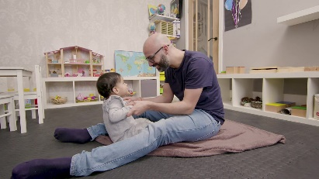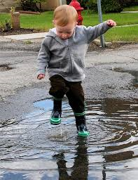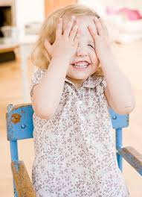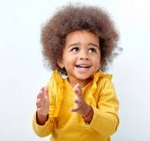

Row, row, row your boat

Action songs

Peek-a-boo

Jumping

*For this example:*

* The adult starts to sing, 🎜‘The Wheels on the Bus’
* During the song, the adult pauses, for example, “The horn on the bus goes…” in the hope that the child will respond showing interest, this may include finishing the line, glancing at the adult, smiling, etc.
* If the child does respond, try not to comment on their response, just carry on with the song.
* If the child doesn’t respond, carry on and pause again at a different part of the song.

*Sensory people games, examples:*

Adult sings 🎜‘Incy, Wincy Spider’ while gently walking their fingers on the child’s arm. Adult to randomly stop singing and pauses their fingers on the child’s arm to wait for a response before continuing.

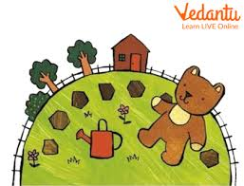

Adult sings 🎜‘Round and Round the Garden, like a Teddy Bear’ while using their finger to make circles on the child’s hand.

*Physical people games, examples:*

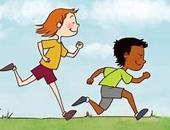Adult joins the child in the garden when the child is running around. When the child stops, the adult says ‘Ready, Steady…’ in an exciting voice and then pauses and waits for a response, before the adult says, ‘Go’. Both adult and child then run together.

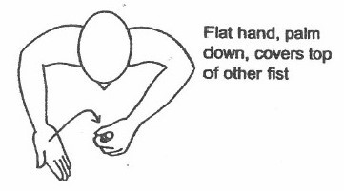

\\serverd\staffareas$\Jjudge\pictures\more 2 (4).jpgAt the end of this short activity, if the child is still interested, maybe encourage the child to request ‘more’ - this could be verbally, with a gesture, glancing at the adult, or maybe using the sign for ‘more’. Initially, you may need to model this using hand over hand.

Continue with this until the child is responding consistently (remember - not just a one off).