

**MAIDSTONE SPECIALIST TEACHING & LEARNING SERVICE**

**Leaflet / Information Sheet**

|  |
| --- |
| **Establishing Joint Attention: With Resources** |

This is the same as People Games, but you now include a resource to encourage the child to focus on both the adult and the activity. This is called **focussed** attention, and the child can focus and refocus their attention by themselves, however this is only at one activity at a time. This will be noticeable as the child looks between the object and the adult to communicate their shared interest.

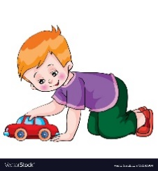*For example:*

When playing a Ready Steady Go game, an adult would join the child playing with a car. Adult says ‘Ready, Steady…’ in an exciting voice and then pauses and waits for a response before saying, ‘Go’ and pushing a car towards the child.

The child is holding a vibrating ball, an adult comes alongside and pauses the toy and says, ‘Ready, Steady…’ in an exciting voice and then pauses and waits for a response before saying ‘go’ and starting the toy again. The way the child communicates could be verbally, a gesture, eye contact, smiling, reaching for, etc.

The child is splashing in the water, an adult comes alongside splashes in the water and then the adult pauses, waits for a response before continuing with the splashing.

This may include ready, steady go. 1, 2, 3. etc.

This should be with different adults, with a range of resources and in various situations.

